

**Game Design Document**

**Whatever it Takes**

**Professor**

Carmelo Macrì

**Team members:**

Crudo Giovambattista (ID: 213546)

Blefari Carmine (ID: 213535)

Tassone Gabriele (ID: 213596)

Maresca Alessio (ID: 213547)

Marasco Giovanni (ID: 213622)

**Academic Year 2021-2022**

*Intentionally left blank*

**Index**

**1 Game Overview…………………………………………………..**

**1.1 General informations**………………………………………………………….

**1.2 External influences**……………………………………………………………..

**2 Story and setting…………………………………………………**

**2.1 Summary**…………………………………………………………………………….

**2.2 Characters**…………………………………………………………………………..

**3 Gameplay…………………………………………………………..**

**3.1 Introduction**………………………………………………………………………..

**3.2 Controls**………………………………………………………………………………

**3.3 Player Mechanics**……………………………………………………………….

**3.3.1 Player Status**………………………………………………………………………….

**3.3.2 Movement System**………………………………………………………………..

**3.4 Other objects and characters mechanics**………………………….

**3.5 Game system mechanics**………………………………………………….

**3.5.1 Loading and Saving**………………………………………………………………

**3.5.2 Scenes Managment**……………………………………………………………..

**3.5.3 Story Events**………………………………………………………………………...

**3.6 Victory and Game goals**……………………………….

**4 Game Dynamics…………………………………………………**

**4.1 Introduction**…………………………………………………………………….

**4.2 Player**………………………………………………………………………………

**4.3 Enemies**…………………………………………………………………………..

**5 UI Design…………………………………………………………..**

**5.1 Main Menu**……………………………………………………………………..

**5.2 In game HUD**…………………………………………………………………..

**6 Level Design………………………………………………………**

**6.1 Zones’ and story events’ description**……………………………..

1 Game Overview

1.1 General Information

* Single player, Open World with Main Quests
* Genre: Third Person Shooter
* Platform: PC

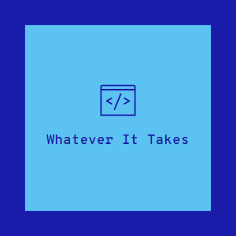

1.2 External Influences

The development of this game has been influenced by Grand Theft Auto, a series of videogames created and developed by Rockstar North, Rockstar Leeds and published by Rockstar Games.

##GAME NAME## is a GTA style game with Third Person camera and a main quest to be completed. One has the Possibility to explore the world map in order to find objects and informations about the environment.

Another inspiration for our game is Dark souls. It helped us with learning how to handle boss fights, boss characterization and collectibles. We’ve been inspired by the way dark souls or souls-like games have collectibles to push you towards exploring world map in general, making it more interesting to wander around and spending time trying to catch all of them.

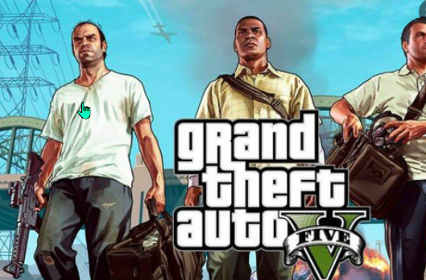 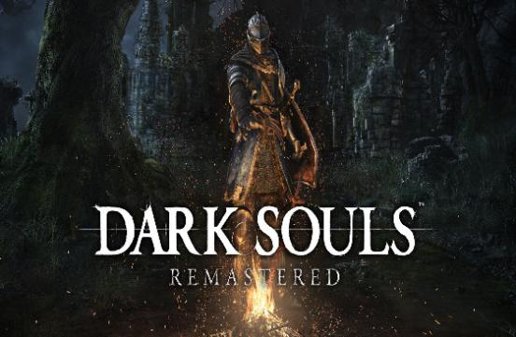

2 Story and setting

2.1 Summary

***FreshMan*** is a university freshman who has just been admitted to the degree course of computer science at the University of Calabria(UNICAL), an Italian excellence in the field of technology and artificial intelligence.

The adventure begins at the Residential Centre where ***FreshMan*** must collect his university card and request the credits for ESSE3, the site on which the exams he will pass will be registered. Because of his poor economic conditions ***FreshMan*** is immediately informed of being eligible Beneficiary of the scholarship, however to obtain the full amount he will have to complete exams for a total of 24 credits(also called CFU’s). As soon as he leaves the residential center he is escorted to his residence where he will find his bed, a desk and a PC on which he can view his university situation at any time. Leaving the residency he will come into contact with the fantastic world of UNICAL and will start studying to pass all the exams.

2.2 Characters

We used characters and animations from mixamo.com , also people walking on the bridge are taken from this web site.

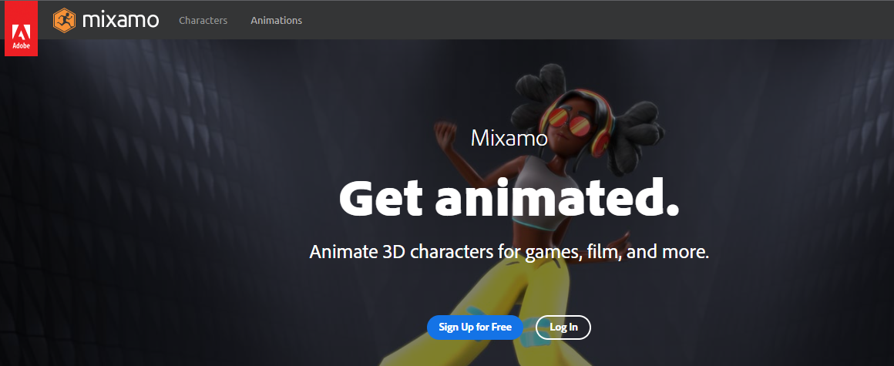

2.2.1 The main character  
***FreshMan*** is a university freshman that has just moved to the UNICAL college. Its tools are a smartphone and a Raspberry Pi.

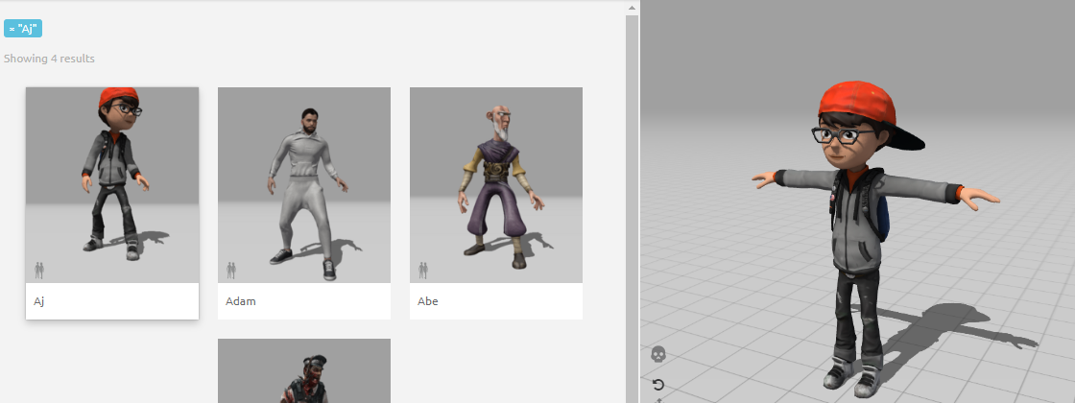

2.2.2 Bosses

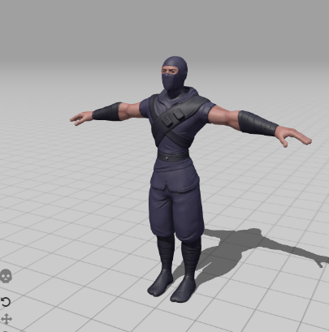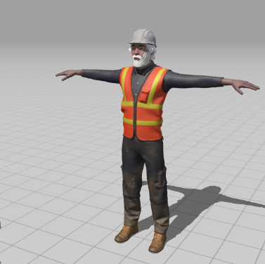

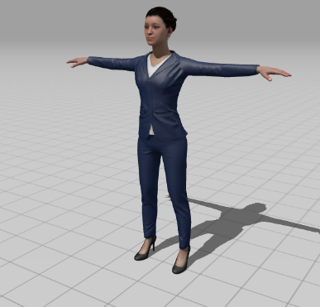

1. Pimona Serri: Teaches Computer Science 101, skilled in USB drive throwing, works as an introductory boss.
2. Darmine Codaro: Teaches Objected Oriented Programming, shoots CPUs.
3. Riancesco Fricca: Teaches Software Engineering, shoots with Cif disinfectant.
4. Super Pimona Serri: Teaches Artificial Intelligence, has a robot in front of her that shoots towards the character, when killed, he’ll double himself after 3 seconds.
5. Super Darmine Codaro: Teaches User Interface Design, in order to beat him you have to use the items that surround to avoid his attacks.
6. Iovambattista Gianni: Teaches Operative Systems, will be the final boss. He will be a mix of all the kinds of fight that happened before him.

3 Gameplay

3.1 Introduction

The game starts with our main character taking his University Badge at

The Residential Centre. This will work as a Tutorial, helping the player

with the game commands.

3.2 Game Commands

|  |  |
| --- | --- |
| TASTI | AZIONE |
| W | FORWARD WALK |
| S | BACK WALK |
| D | RIGHT WALK |
| A | LEFT WALK |
| SPACEBAR | JUMP |
| MOUSE | LOOK AROUND |
| E | INTERACT |
| I | INVENTORY |
| LEFT MOUSE | FIRE |
| RIGHT MOUSE | AIM |
| R+MOVEMENT | RUN |

3.3 Player Mechanics

Player mechanics in WIT are the following:

* Player Movement
* Fighting System

3.3.1 Player Status

* Health: Health is used to determine Freshman’s HP which are determined by it starting HP, damage taken and life restored
* Ammo: Ammos are used to Damage enemies
* Coins: #######AGGIUNGERE#######

3.3.2 Movement System

Movement's mechanics are meant to let the player exploring the ship’s environment both horizontally and vertically.

* **TPS view:** character’s body is controlled via mouse and the play-view is in Third person style.
* **Walking:** the player can walk using WASD keys.
* **Running:** while R key is pressed the character will run doubling his normal speed.
* **Jumping:** the player can perform a jump pressing the Spacebar key. This may help him passing on little obstacles.
* **Falling:** Under this status the player can move foreward.

3.4 Other Objects and Character Mechanics

* Wandering Students
* Vending Machines

3.4.1 Wandering Students

They walk up and down the main bridge without having any

Interaction with FreshMan

3.4.2 Vending Machines

Vending Machines are the main way to get Life or Ammos

3.5 Game System Mechanics

* Saving
* Scene Changing

3.4.1 Saving

####IMPLEMENTARE#####

3.4.2 Scene Changing

When the player reaches a door that is programmed

In order to trigger a Scene Changing one it will automatically

Happen

3.6 Victory and Game Goals

The way in which WIT ends is by killing all the bosses, and finally

Getting our degree. There is no game over, if one dies it will

Automatically reload last saved checkpoint

4 Game Dynamics

4.1 Introduction

Our main Goal is to induce fun in the player, who will

be mainly a Student from Unical. He will enjoy the Game

by encountering already WELL-known Bosses.

Each boss will be slightly harder and forcing the player to

Learn the game in different ways.

4.2 Player

The player main way to fight is by shooting USB drives,

And auto attack that is a random choice between punch and kick.

4.3 Enemies

Enemies are represented by the bosses , they are situated in the Arenas.

Enemies can respond to the main player attacking with fireballs.

They have life increasing from first boss to the last.

5 UI Design

5.1 Main Menu



The Main Menu is very simple , allows you to start the game (play) , quit it (quit) or change the audio options (options).

We opted for a simple but optional menu to facilitate learning.

5.2 In Game HUD

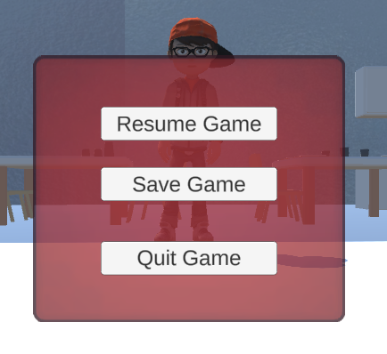

The pause Menu is useful to take a pause from the game, clicking the ESC command , quit the game returning to main menu or saving current game updates.

Also we can resume game and keep playing.

6 Level Design

6.1 Zones and story events description

Bridge.

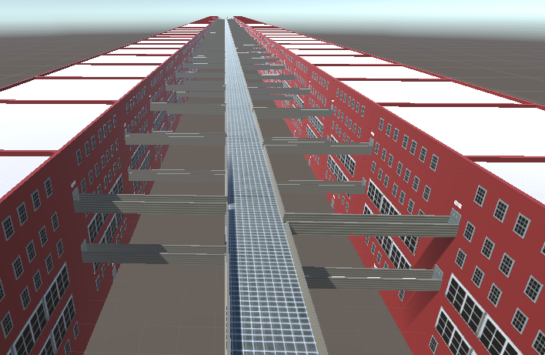

The principal scene of the game is the bridge.

It represents an important element at Unical and in our game.

Here are people walking randomly.

Also there are all the cubes inspired by reality , the length of the bridge is inspired too.

Our character can walk , run , jump and access the various arenas or restricted areas.

Arenas

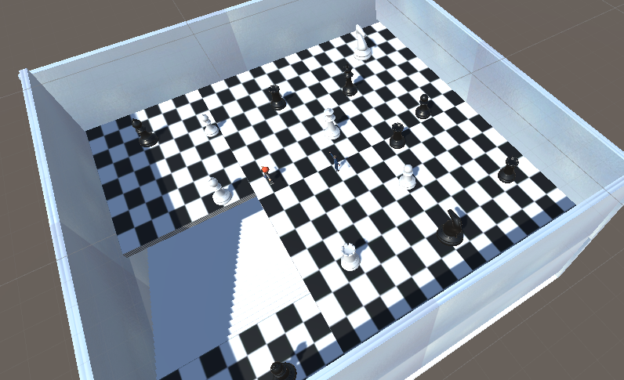

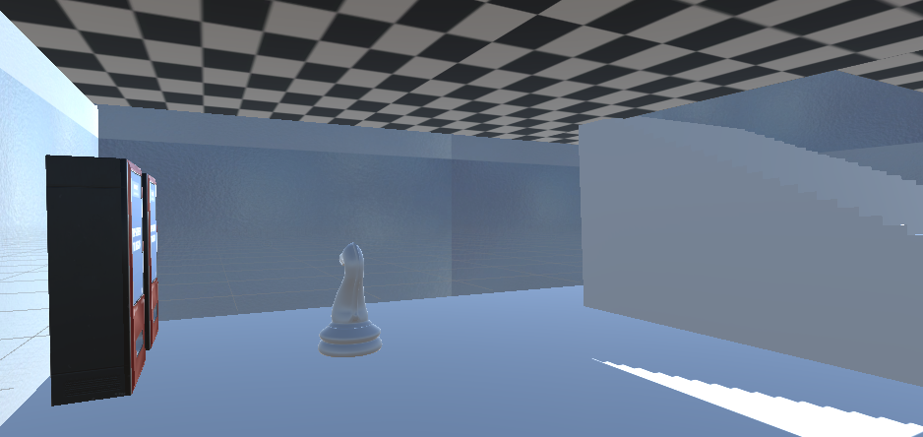

This is the first arena , inspired to chess game.

Here our main character can fight against the first boss Pimona Serri.

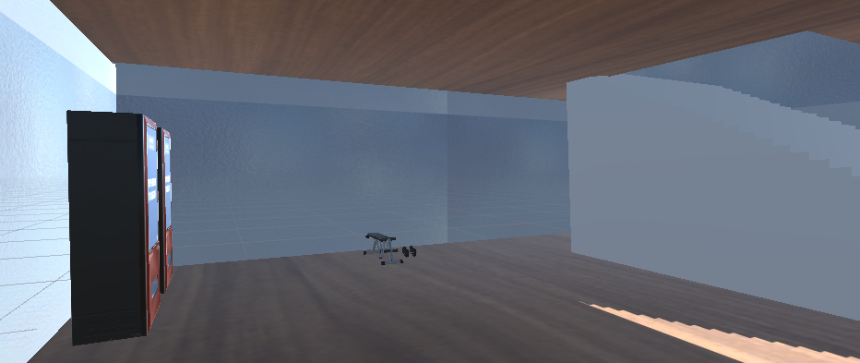

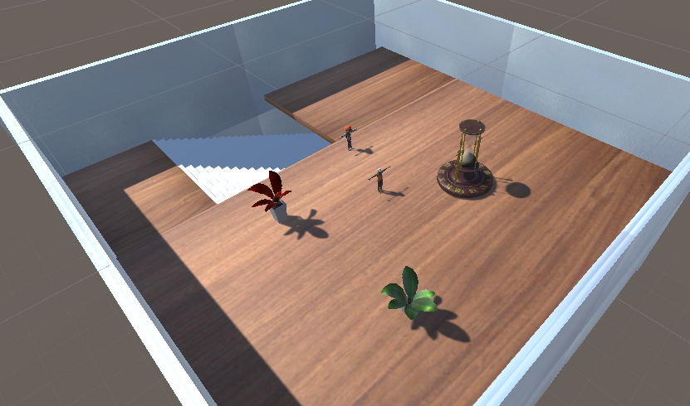

This is the second arena , inspired to a desk.

Here our main character can fight against Iovambattista Gianni.

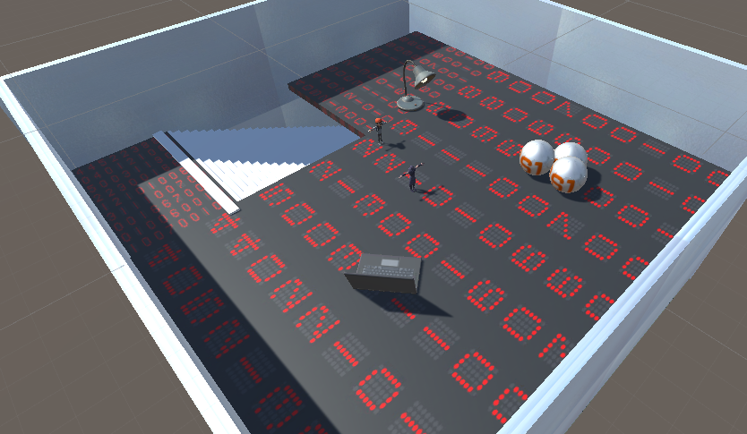

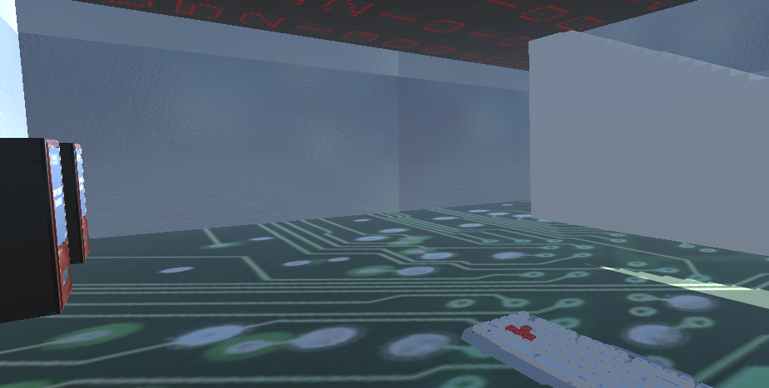

This is the third arena , inspired to a computer.

Here our main character can fight against Darmine Codaro.

In all the arenas our main character can fight only on the floor.

The bossed won’t follow him down stairs.

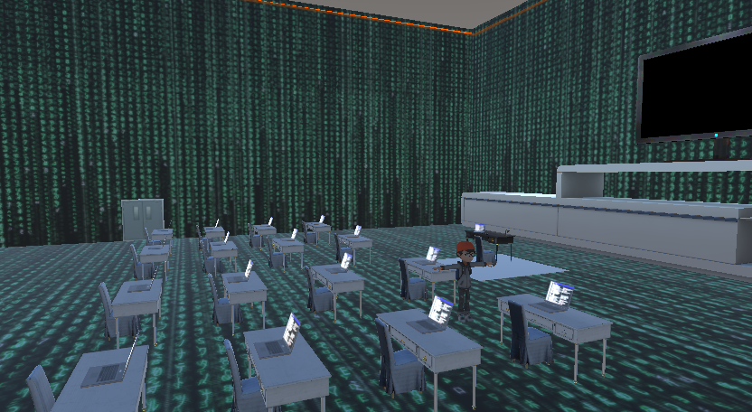

This is the coding room , inspired to a matrix room.

Here our main character can improving himself using his abilities of programmer.

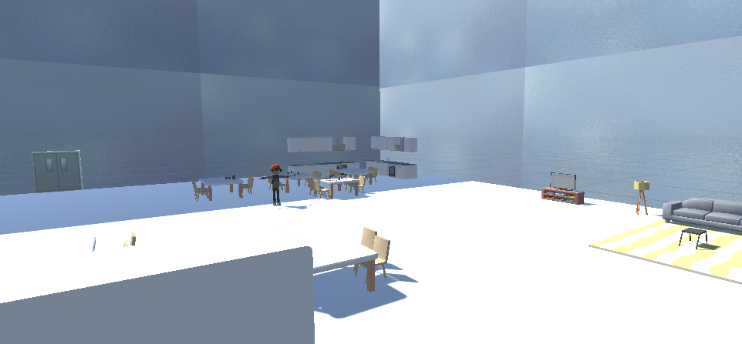

This is the school canteen.

Here our main character can recharge himself EATING.